Chatfield Bioreactor Test Results – 3/25/2015

Here is a picture showing the current results of the bioreactor test.
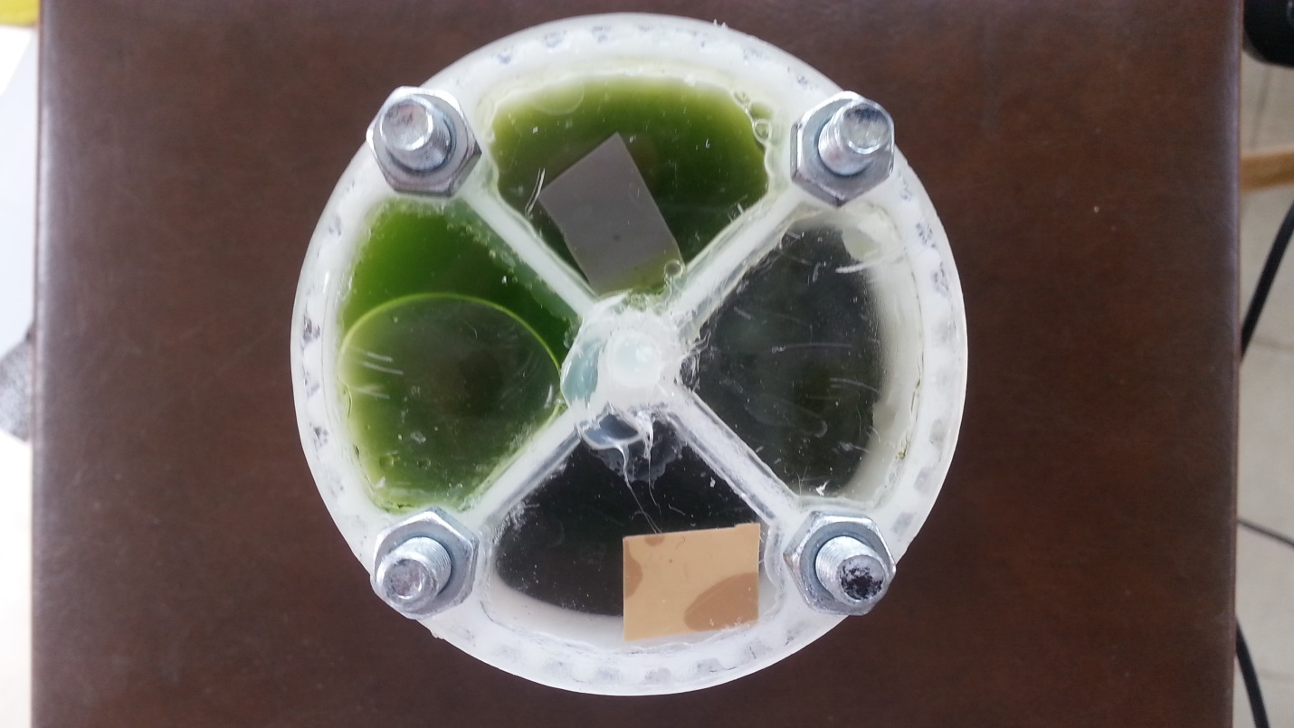

The top section shows the Chlamy in the section with the gas permeable membrane removed. The gray color confirms hydrogen production. In the right quadrant there was Chlorella but the membrane failed and the solution leaked out. We will use caulk on the next test to seal the joint between the top and bottom sections of the bioreactor from the outside, insuring that no solution will leak from the reactor even if the membrane separating the two sections fails. In the bottom quadrant is Chlamy with the membrane separating the hydrogen tape from the solution – no color change noted. It seems that the hydrogen does not move easily across the membrane. This will be monitored to see if there is a color change. In the left quadrant is Chlorella with the membrane keeping the solution at the top of the bioreactor so that our camera will be able to watch its progress. The color is good on all solutions indicating that the algae are healthy. The test began on Friday 3/20 with no cold stow. Next tests will include cold stow for 5-7 days with magnesium sulfate to retard hydrogen production.

