Chatfield Bioreactor Loading Procedure – 3/20/2015
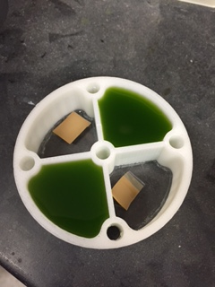 Figure 1
Chlorella is loaded into two sides of small section of bioreactor. Hydrogen tape is seen in the other two sections. On the bottom a circle of plexiglass has been glued in place.

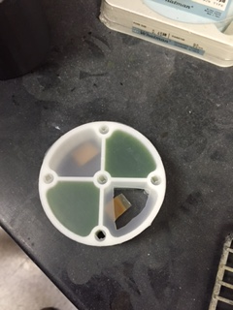 Figure 2
Gas permeable membrane is placed over small section. The cut in the upper right section is to test if we need to keep the hydrogen tape separate from the solution and to test on the lower left if the gas permeable membrane allows the hydrogen to pass.
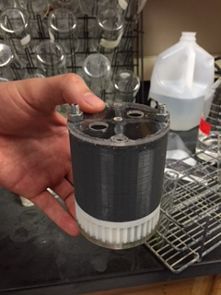Figure 3
The large section is secured in place with nuts and bolts
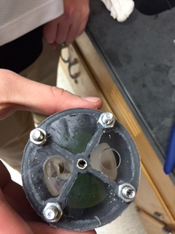

Figure 4

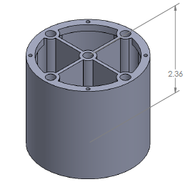
The holes shown (Figure 4) were used to fill these sections with Chlamy. They were stoppered in our test, but we plan to close them with plexiglass and caulk in the later tests. In our final design we hope to use a slight modification to the large section that you see in Figure 5, which would allow us to use helicoils to close our reactor rather than gluing the plexiglass in place. The difference in the design is that there is a thicker rim with holes for helicoils. We will likely need to widen the central supports so that we can add more helicoils to the central supports for a better seal. The thick outer ring would then be extended along each divider in the tube with holes for helicoils. We would then seal this design with a gasket made from our aquarium caulk. We have a template that allows us to fill it with the caulk, scrape off the excess and then have a flat gasket perfectly sized for the bioreactor. We tried one of these gaskets with the Chlamydomonas reactor but didn’t have helicoils to secure it, so we are not sure at this time if the gasket will work. One of the first tests upon return to school is to test the gasket with the helicoils in place. We now have the tools we need for the helicoils and extra helicoils to test this. If this process is liquid tight, it will eliminate the need for the large holes in the bottom section of the bioreactor as shown in Figure 4.
Figure 5
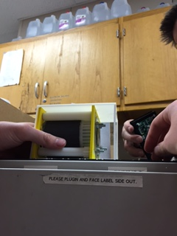 Figure 6
Everything in place ready to load into nanolab in Figure 6. We had a problem getting the gearing to work, so our test over the student’s spring break will be to test survival and gas production in the bioreactors. We will fix the problems with the gearing when we return.
A final note on which design looks most favorable and that we are working on. In the design shown here we have combined some aspects of each design. We are currently planning to use the Chlorella design for the housing (Figure 7) and a modified bioreactor design as shown in the Chatfield Bioreactor Design 3.17.2015 – a separate document. The outside box can be seen in an update post from 3/11 on the chatfieldndc.weebly page for the spin test. Our gearing test of Friday 3/20 indicated an unknown problem. We aren’t sure if it was a friction problem or a problem of too much mass with the solutions in the bioreactor. We will address this upon return. One possible change will be to add o-rings back on the roller shown in Figure 7 – the small indentations are to secure them in place. This may reduce friction and allow for a smoother spin. We will make these modifications upon return and test to see if they eliminate the problem of a non-spinning bioreactor.

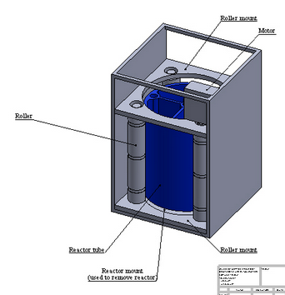 Figure 7

