Chatfield Bioreactor Design – Combined
17 March 2015

In the latest design, we plan to use the bioreactor below for both strains of algae.

For Chlorella: the upper section will be used for the algae and the bottom will serve as headspace.
For Chlamydomonas: The bottom section will be used for algae and the top will serve as headspace.
Current plans have two sections being used for Chlorella and two sections for Chlamydomonas. Both algae will be in solution – Bold’s Basal Medium for the Chlorella and TAP-S for the Chlamydomonas. The approximate volume of solution for the Chlorella will be about 40 mL and about 150 mL for the Chlamydomonas.
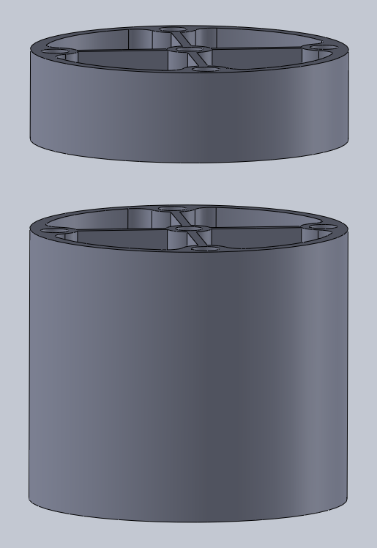
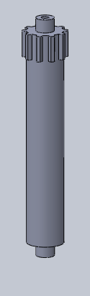
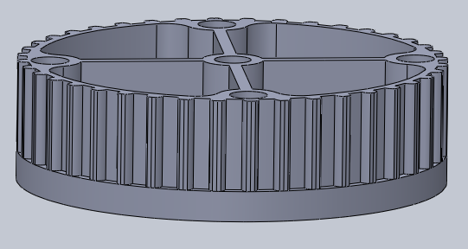
The top and bottom of the reactor will be sealed with clear plastic (either plexiglass or polycarbonate depending on our ability to cut each – we have been experimenting with a new cutting technique that may allow us to still use the polycarbonate to seal the reactor) The covers will be glued in place using the aquarium adhesive. In between the top and bottom section we will have a gas permeable membrane, allowing for gas transport while keeping the algae contained. The two sections will be held together using bolts that run the length of the reactor. Finally, the top section has been updated to include gearing around the circumference. One roller has been modified also to include gearing on the top to spin the reactor as shown.

